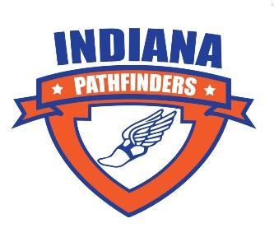
Indiana Pathfinders Youth Cross Country Club
2021 Sponsor Application
Thank you so much for supporting the Indiana Pathfinders Youth Cross Country Club. We are a youth program of the Columbus Running Club, a non-profit 501©3 organization. Your sponsorship is of tremendous value to us. We depend on sponsors like you! You are helping to develop teamwork, sportsmanship, work ethic, and character among our youth participants, while promoting the sport of cross country. We are grateful for your generous support!
Sponsorship Level: $300
Company logo will be displayed/printed on the following:
-Columbus Pathfinders Web Page: https://www.runcolumbus.org/youth-cross-country
-Columbus Pathfinders Facebook Page and Program Flyer
-Columbus Pathfinders Spirit Wear (shirts/sweatshirts/hoodies)

Name of company or individual:
Address:
Phone number:
Please provide the email address for where you would like your receipt to be sent:

Your donation is tax deductible.
Please make check payable to Columbus Running Club, and return this application with your check to:
Christina Newell
15330 East 200 South
Columbus, IN 47203
*Please submit application and check by 9/15/21 to ensure placement of your name/logo on the qualifying items. Email logo to newelldni@aol.com by 9/15/21. For questions, call/email Christina Newell: (812) 350-7005 newelldni@aol.com

